Daphne High School Band Booster

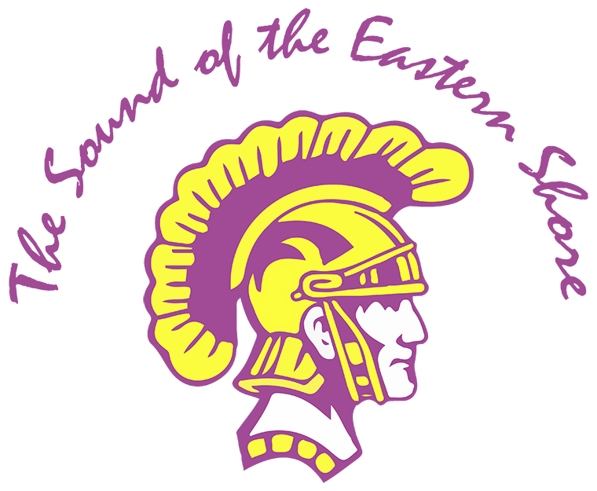

P. O. Box 2162

Daphne, AL 36526

**DHS Band Booster Meeting 04/08/25**

Date/Time: 04/08/25 6:00 pm

# Facilitator: Michael Mergell

Location: DHS Band Room

# 6:05 pm - Meeting Called to order by: MM

# 

# **In Attendance**

Michael Mergell (MM), Angela Brewster (AB), John Brewster (JB), Amon Walker (AW), Sheryl Wainwright (SW), Lisa Evans (LE), Jamar Dumas (JD), Amy Giorgenti (AG), Terrie Weinacker (TW), Ben Dale (BD),

Missing: Chris LeBatard (CL), Jacob Moorer (JM), Dr. Bill Davidson (DBD)

Total Attendance: 14 (including board members)

# **Approval of Minutes**:

# **Officer Reports:** N/A

# **President: (MM)**

* Reviewed the two ways to help the band:
  + Volunteer
  + Financial Contribution
* Shared photos and stories from the recent NYC trip.
* Discussed upcoming Spirit Night to be held at Taco Mama on Monday 4/28 from 5pm-8pm.
  + A portion of the sales are returned to the band. Please consider coming out and supporting the Sound of the Eastern Shore and enjoying some great food.
* DHS Band Banquet will be Thursday (5/8). Planning is underway now and there are multiple opportunities for anyone who would like to help.
* Taste of the Eastern Shore will be Saturday (8/23) from 6pm-10pm at the Daphne Civic Center.
  + Tickets prices will stay $50 as in previous years and will go on sale soon.
  + Invite your friends and family members to come out for a great night of local food, entertainment and music by the Moly Ringwalds.

**(Officer Report cont. MM)**

* Asked everyone in attendance to consider serving or nominating someone (with their permission) to serve on the Booster Board or as a Chairperson for 2025-2026.
  + The new Executive Board will be voted on at the stated May Booster meeting and will take office in June.
    - 2025-2026 Board Returning Officers:
      * **President:** Ben Dale
      * **Treasurer:** Sheryl Wainwright
    - 2025-2026 Current Board Nominations:
      * **Deputy Treasurer:** Karen Moore
      * **Secretary:** Traci Parckys
    - 2025-2026 Current Board Openings (Nominations Needed):
      * **Deputy Vice President: open**
  + The new Chairpersons will be approved at the May Booster meeting and will begin in June.
    - 2025-2026 Chairpersons Returning:
      * **Fundraising**: Amy Giorgenti
      * **Chaperone:** Lisa Evans
      * **Uniforms:** Terrie Weinacker and Jennifer Jones
      * **Signup Genius:** Angela Brewster

* + - 2025-2026 Current Chairperson Nominations:
      * **Auxiliary:** Traci Parckys
      * **Vehicle/Motor Pool:** Amon Walker
    - 2025-2026 Current Chairperson Openings (Nominations Needed):
      * **Eastern Shore Classic: open**
      * **Hospitality: open**
      * **Equipment/Pit: open**
      * **Parking: open**
  + **If you are interested in serving, please contact MM or AW for additional information and/or nomination forms.**
* UPCOMING EVENTS:
  + April 9-12 - Allstate Festival in Mobile
  + April 14-18 – Spring Break
  + April 22 - 25 – Auxiliary Auditions
  + April 22, 24 – Drum Major Clinic
  + April 22 – Leadership Application Due
  + April 23 – Leadership Interviews
  + April 25 – Pep Rally
  + April 28 – DMS Concert
  + April 29 – Percussion Concert
  + April 30 – Drum Major Auditions
  + May 1 – Spring Concert
  + May 6 – Elementary Band Concert
  + May 8 – Band Banquet
  + May 9 – Leadership Announced/Online Registration Deadline
  + May 12 – 15 – Freshmen Orientation/New Member Camp – all leadership
  + May 13 – Booster Meeting
  + May 16 – Band Cookout and Spring Game
  + May 21 – Graduation
  + May 22 – Last day of school

**Vice President: (BD)**

* 4/28 is the DMS Concert in Trojan Hall. We will have a table set up to talk to any incoming 2025-2026 Freshman band parent(s) about the Band Booster organization and how they can get plugged in and serve.
* Information will be given about chaperone requirements (BiB cards), Box Truck drivers licenses (BCBE requirements), open chairperson(s), executive board member positions, and the various ways/opportunities that they can help The Sound of the Eastern Shore.
* If you would like to participate in this recruiting event or would like more information, please contact BD.

**Treasure:** **(SW)**

* SW presented the financial report for the month of February.
* Current account balances were presented to those in attendance.
* Information was given out on how to view financials online at <https://daphne.band>.

Deputy Treasurer: **N/A**

Secretary: **N/A**

**Director’s Report: (JD)**

* Presented information for the potential campus layout for the summer/fall based on current construction plan.
* Informed the group about the Trojan Hall renovations that should start this summer. Renovations include removing basketball goals, carpet, and installing acoustic panels.
* The fountain in front of Trojan Hall will be removed during spring break. The plan is to eventually move the Trojan statue currently located in front of the school’s main entrance and place it in this area.
  + The boosters are planning to offer the opportunity, for anyone interested, to purchase new bricks as a memorial fundraiser to go around the statue once it has been moved. Be on the lookout for more information about this unique and special opportunity to support the band in the coming months.

# **Committee Reports:**

# Chaperone: **N/A**

Uniform: **N/A**

Parking: **N/A**

Pit: **N/A**

**Fundraising: (AG)**

* Received a check from Eastern Shore Lanes for our most recent spirit night in March.

**Auxiliary: Traci Parckys**

* Preliminary planning has begun for the Winterguard to go to the National Competition in Dayton, Ohio in 2026. Looking at fundraising ideas, as well as a trip feasibility.

# **OLD Business:**

# **New Business**:

# **Announcements**: Next Stated Booster meeting will be held ­­­­­May 13th at 6:00 pm in the Band Room. Please make plans to join us!

# **Adjournment:**

Time: 6:47 pm

Motioned by: MM