Daphne High School Band Booster
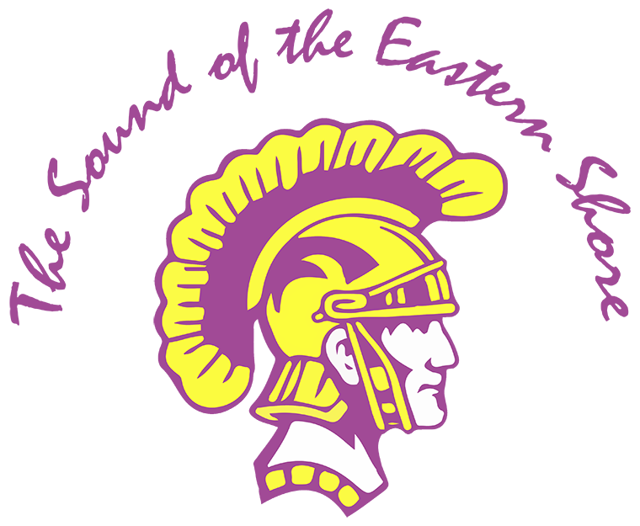

P. O. Box 2162
Daphne, AL 36526

DHS Band Booster Meeting 05/13/25

Date/Time: 05/13/25 6:00 pm

Facilitator(s): Ben Dale/Jamar Dumas
Location: DHS Band Room

6:07 pm - Meeting Called to order by: JD

In Attendance
Michael Mergell (MM), Angela Brewster (AB), John Brewster (JB), Amon Walker (AW), Sheryl Wainwright (SW), Lisa Evans (LE), Jamar Dumas (JD), Amy Giorgenti (AG), Terrie Weinacker (TW), Ben Dale (BD), Chris LeBatard (CL), Jacob Moorer (JM), Dr. Bill Davidson (DBD)

Missing: Chris LeBatard (CL), Dr. Bill Davidson (DBD)

Total Attendance: 75+ (including board members)

Approval of Minutes: N/A

Officer Reports:

President/Vice President: (BD)
- Presented a slide show that contained information about the DHS Band Booster organization, monthly financials, and the different opportunities for volunteering to make the band a success next year.

- Reviewed the two ways to help the band:
  - Volunteer
  - Financial Contribution

- Asked everyone in attendance to consider serving or nominating someone (with their permission) to serve on the Booster Board or as a Chairperson for 2025-2026.

- Encouraged the upcoming freshman parents to become involved and help support The Sound of The Eastern Shore.

- Reviewed the outgoing Band Boosters Executive Board and presented the nominations for the 2025-2026 Executive Board.

  - The new Executive Board members were voted on and approved. They will take office on June 1st.
    - 2025-2026 DHS Band Booster Executive Board Officers:
      - President: Ben Dale
      - Vice President: Phu Vuong
      - Treasurer: Karen Moore
      - Deputy Treasurer: Heather Reese
      - Secretary: Traci Parckys

  - The new Chairpersons were approved and will begin the yearly term on June 1st.
    - 2025-2026 Chairpersons:
      - Fundraising: Amy Giorgenti
      - Chaperone: Lisa Evans
      - Uniforms: Terrie Weinacker and Jennifer Jones
      - Signup Genius: Angela Brewster
      - Auxiliary: Traci Parckys
      - Vehicle/Motor Pool: Amon Walker
      - Equipment/Pit: Jason Broadwater
      - Hospitality: open
      - Eastern Shore Classic: open
      - Parking: open

  - Thanked the following people for serving on the Executive Board for the 2024-2025 school year as officers.
    - Michael Mergell (president)
    - Sheryl Wainwright (deputy treasurer/treasurer)
    - Amon Walker (secretary)

  - If you are interested in serving or just want additional information about one of the open positions, please contact BD at benjamin.m.dale@gmail.com.

- UPCOMING EVENTS:
  - May 12 – 15 – Freshmen Orientation/New Member Camp – all leadership
  - May 16 – Band Cookout
  - May 21 – Graduation
  - May 22 – Last day of school
  - May 31 – Parent Workday (paint/cleaning) 8am-1130am

Vice President: (BD)
- See above as BD lead the meeting and presented as President for MM.

Treasure: (SW)
- Presented the financial report for the month of April.
- Current account balance sheets were available for those in attendance.
- Information was given out on how to view financials online at https://daphne.band.
- Reviewed some of the Financial accomplishments from the 2024-2025 year:
  - Over $111,000 in total money raised through fundraisers (ToES/ESCC/Spirit Nights/Donations)
  - Outfit one of the new DHS Band trucks with shelving
  - Backup cameras installed on Band Trailer and both DHS Band Trucks
  - Major front-end overhaul and maintenance completed on the Dually Band Truck
  - Wrapped the 36ft Band Trailer to match the Band Trucks
  - Leveling, resurfacing, and sod replacement to the Faison Band Practice Field

Deputy Treasurer: N/A

Secretary: N/A

Director’s Report: (JD)
- A slide show presentation was given to the upcoming Freshman parents and all in attendance as an Introduction to The Sound of The Eastern Shore
  - This presentation included:
    - Director and Staff contact information
    - What is expected from the students and parents
    - General explanation of the different bands and ensembles throughout the year
    - The schedule for band camp in July
    - Associated band costs and participation fees throughout the year.
    - Reviewed BiB card process and BCBE guidelines
      - Anyone who volunteers as a chaperone, PIT member, Truck Driver and/or will be around the students MUST have a current BiB card.

- Reminder that if any student wants to be a part of The Sound of the Eastern Shore and experiences a financial hardship, please contact Mr. Dumas directly. Everything will be handled confidentially as there are opportunities to help students and families from a financial standpoint. The directors want each student, who has a desire to be part of the DHS Band, to have the opportunity - regardless of the financial situation.

Committee Reports:

Chaperone: (LE)
- Presented information to parents about what chaperones do at each game and competition, BiB card requirements (BCBE not DHS Band), and other volunteer opportunities (band camp/first aid) for chaperones and where to find the required forms online.
- There will be chaperone training held during Band Camp in July.

Uniform: (TW)
- Discussed uniforms and the need for volunteers to help measure, clean, organize and repair uniforms throughout the marching season. NO SEWING EXPEIRENCE REQUIRED.

Parking: N/A

Pit: Jason Broadwater
- Explained what the PIT Crew does each week for ALL football games (home and away) and competitions as it relates to getting equipment to/from and on/off the field and trucks.

SignUp Genius: (AB)
- Explained to those unfamiliar with it; what SignUp Genius is and how we use it as an organization.
- Encouraged everyone present to be on the lookout as we get closer to band camp for notifications on how to volunteer and sign up through the app for slots to help support your kids and The Sound of the Eastern Shore.
- Discussed other ways to help the band through financial giving or entire meal sponsorships for band camp/game days/competitions in the fall.

Fundraising: (AG)
- Taste of the Eastern Shore will be Saturday (8/23) from 6pm-10pm at the Daphne Civic Center.
  - Tickets prices are $50 as in previous years and will go on sale soon.
  - Invite your friends and family members to come out for a great night of local food, entertainment and music by the Moly Ringwalds. This is their final tour!!
  - Reminder that if you volunteer for a shift you get in free.
  - Presented a barcode for Signup Genius and encourage those present to consider volunteering.

Vehicle/Motor Pool: (AW)
- Explained what this group does each week in the fall for games/parades/competetions as well as in the Winter/Spring for the auxiliary season.
- Explained that all drivers must be certified through the county by the BCBE in order to drive the DHS Band Box Trucks.
- The date for driver training through BCBE is TBD. Once the date has been finalized it will be sent out to anyone interested.
- Asked everyone in attendance to consider volunteering as there is a need for drivers throughout the year.

Auxiliary: Traci Parckys
- Please consider being a volunteer if your child is a member of the Axillary team. They are an integral part of the Marching Band in the fall during half time/competetions/parades. During the Winter/Spring they have their competition season.
  - They need volunteers for the following areas:
    - Band Truck Drivers
    - Chaperones
    - Equipment Movers

Old Business:

New Business:

Announcements: Next Stated Booster meeting will be held July 15th (during band camp) at 6:30 pm in the Band Room. Please make plans to join us!

Adjournment:
Time: 7:30 pm
Motioned by: BD

